A. <!DOCTYPE HTML>
<html>
<head>
<meta http-equiv="Content-Type" content="text/html; charset=ISO-8859-1" />
<title>Morgan Importing Project Questions Home Page</title>
</head>
<body>
<h1 style="text-align: center; color: blue">
Database Processing (14th Edition)
</h1>
<h2 style="text-align: center; font-weight: bold">
David M. Kroenke
</h2>
<h2 style="text-align: center; font-weight: bold">
David J. Auer
</h2>
<hr />
<h2 style="text-align: center; color: blue">
Welcome to The Morgan Importing Project Questions Home Page
</h2>
<hr />
<h3>Web Pages For MI Case Questions in the Text:</h3>
<hr />
<p>Question A:&nbsp;&nbsp;&nbsp;
<a href="index.html">
Display this MI Home Page.
</a>
</p>
<p>Question B:&nbsp;&nbsp;&nbsp;
Question B asks for an ODBC data source, not a Web page.
</p>
<p>Question C:&nbsp;&nbsp;&nbsp;
Question C asks to create a view
</a>
</p>
<p>Question D:&nbsp;&nbsp;&nbsp;
<a href="MI-Display-StorePurchasesView.php">
Display CustomerPurchasesView data.
</a>
</p>
<hr />
<p style="text-align: center">
<a href="http://localhost/DBP/index.html">
Return to the DBP Home Page
</a>
</p>
<hr />
</body>
</html>

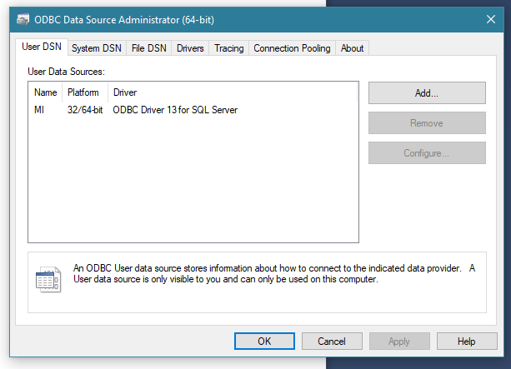
B.
Not exactly sure I did this right, the test failed even with the MI database in place

- CREATE VIEW StorePurchasesView AS
SELECT S.StoreName, S.City, S.Country, S.Email, S.Contact, I.PurchaseDate, I.ItemDescription, I.Category, I.PriceUSD
FROM ITEM AS I JOIN STORE AS S
ON I.StoreID = S.StoreID

D. <!DOCTYPE HTML>
<html>
<head>
<meta http-equiv="Content-Type" content="text/html; charset=UTF-8">
<title>MI-Read-StorePurchasesView</title>
<style type="text/css">
h1 {text-align: center; color: blue}
h2 {font-family: Ariel, sans-serif; text-align: left; color: blue;}
p.footer {text-align: center}
table.output {font-family: Ariel, sans-serif}
</style>
</head>
<body>
<?php
// Get connection
$DSN = "MI";
$User = "MI-CH10A-User";
$Password = "MI-CH10A-User+password";

$Conn = odbc_connect($DSN, $User, $Password);

// Test connection
if (!$Conn)
{
exit ("ODBC Connection Failed: " . $Conn);
}

// Create SQL statement
$SQL = "SELECT * FROM StorePurchasesView";

// Execute SQL statement
$RecordSet = odbc_exec($Conn, $SQL);

// Test existence of recordset
if (!$RecordSet)
{
exit ("SQL Statement Error: " . $SQL);
}
?>
<!-- Page Headers -->
<h1>
The Morgan Importing Purchases View
</h1>
<hr />
<h2>
StorePurchasesView
</h2>
<?php

// Table headers
echo "<table class='output' border='1'
<tr>
<th>StoreName</th>
<th>City</th>
<th>Country</th>
<th>EmailAddress</th>
<th>Contact</th>
<th>PurchaseDate</th>
<th>ItemDescription</th>
<th>PriceUSD</th>
<th>Category</th>
</tr>";

//Table data
while($RecordSetRow = odbc_fetch_array($RecordSet))
{
echo "<tr>";
echo "<td>" . $RecordSetRow['StoreName'] . "</td>";
echo "<td>" . $RecordSetRow['City'] . "</td>";
echo "<td>" . $RecordSetRow['Country'] . "</td>";
echo "<td>" . $RecordSetRow['Email'] . "</td>";
echo "<td>" . $RecordSetRow['Contact'] . "</td>";
echo "<td>" . $RecordSetRow['PurchaseDate'] . "</td>";
echo "<td>" . $RecordSetRow['ItemDescription'] . "</td>";
echo "<td>" . $RecordSetRow['PriceUSD'] . "</td>";
echo "</tr>";
}
echo "</table>";

// Close connection
odbc_close($Conn);
?>
<br />
<hr />
<p class="footer">
<a href="../MI/index.html">
Return to Morgan Importing Home Page
</a>
</p>
<hr />
</body>
</html>

